**The Role of Mediation and Arbitration in Rwanda’s Justice System: Tradition Meets Modernity.**



**Abstract**

This article examines the evolution, legal framework, and practical application of mediation and arbitration in Rwanda’s justice system. It highlights how Rwanda integrates traditional community-based mechanisms with modern statutory reforms to enhance access to justice. It also identifies key challenges and offers recommendations for strengthening Alternative Dispute Resolution (ADR) as a cornerstone of justice delivery in Rwanda.

**1. Introduction**

Access to justice is a fundamental human right and a cornerstone of the rule of law.

In Rwanda, reforms in the justice sector have prioritised efficiency, affordability, and reconciliation. Alternative Dispute Resolution (ADR), particularly mediation and arbitration, has been promoted as a complement to litigation, enabling disputes to be resolved more amicably and at reduced cost.

Mediation and arbitration have long-standing roots in Rwandan culture but have also been institutionalised through legislative reforms and specialised institutions such as the Kigali International Arbitration Centre (KIAC). This paper explores the historical underpinnings, legal framework, and impact of ADR in Rwanda, while critically assessing its challenges and future prospects.

**2. Historical and Cultural Foundations of ADR in Rwanda.**

**2.1. Abunzi (Mediation Committees)**

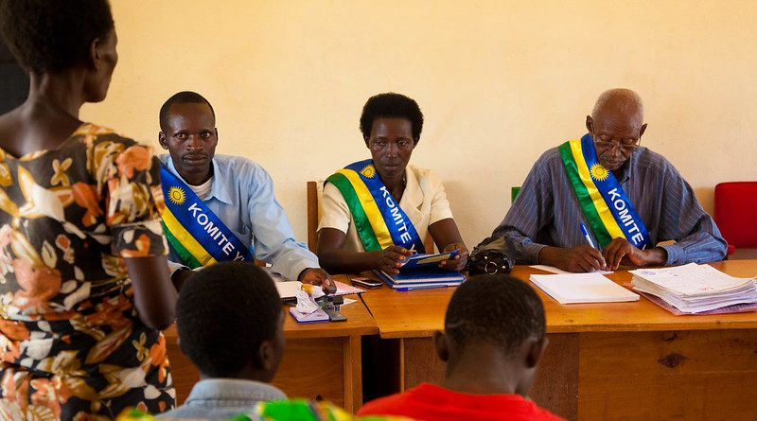

The Abunzi system was formally reintroduced by the *Organic Law No. 02/2010/OL of 09/06/2010,* establishing Mediation Committees at the cell and sector levels. Members are elected by the community, and the law requires that at least 30% be women, underscoring Rwanda’s commitment to gender equity. Abunzi embodies traditional reconciliation mechanisms, providing citizens with affordable and community-driven dispute resolution.

**2.2. Gacaca Courts**

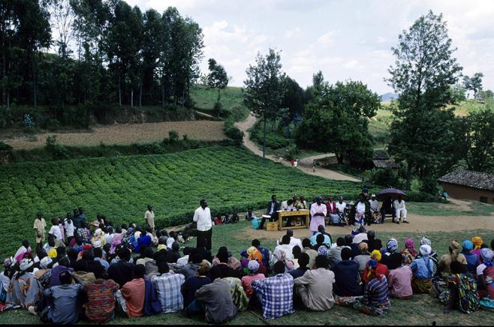

Following the 1994 Genocide against the Tutsi, Rwanda enacted *Organic Law No. 40/2000 of 26/01/2001* to establish Gacaca courts. These community-based tribunals sought truth, reconciliation, and accountability for genocide-related crimes. Although criticised for limited procedural safeguards, Gacaca contributed significantly to social healing and laid the groundwork for modern ADR approaches.

**3. Legal and Institutional Reforms**

**3.1. Court-Annexed Mediation**

*Law No. 21/2012 of 14/06/2012* relating to the Civil, Commercial, Labour, and Administrative Procedure Code (as amended in 2018) incorporated mediation into judicial proceedings. Judges and registrars are empowered to mediate disputes in civil, commercial, labour, and administrative matters, promoting consensual settlements before litigation is finalised.

**3.2. National ADR Policy (2022)**



In 2022, the Ministry of Justice launched the National ADR Policy mandating pre-filing mediation in certain cases. This policy promotes restorative justice and encourages the use of ADR mechanisms as integral to Rwanda’s justice system rather than merely alternatives.

**3.3. Kigali International Arbitration Centre (KIAC)**

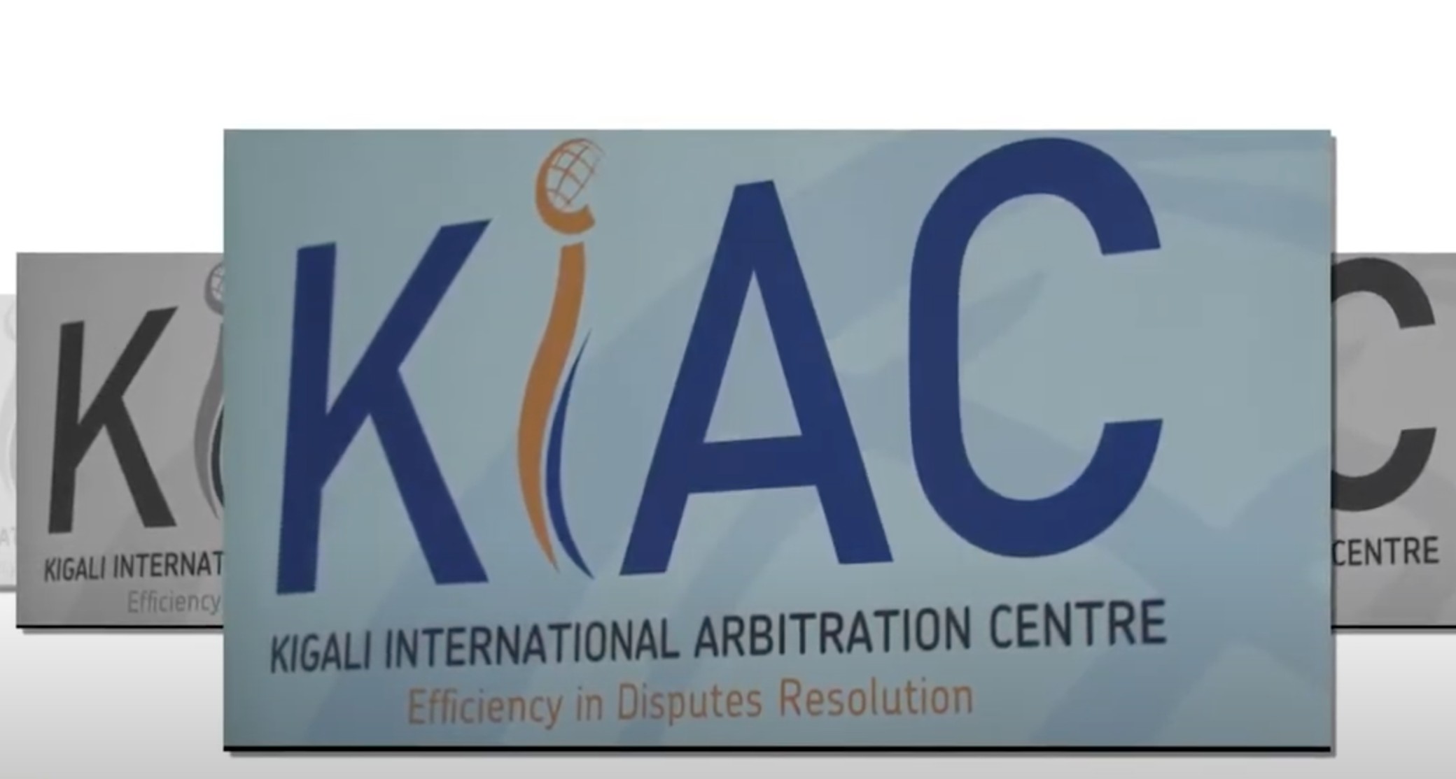

KIAC was established under *Law No. 51/2010 of 10/01/2010* with a mandate to administer arbitration and mediation proceedings. Operating under the *UNCITRAL Model Law on International Commercial Arbitration (1985, as amended in 2006)*, KIAC has positioned Rwanda as a regional hub for international arbitration.

**3.4. Infrastructure Development**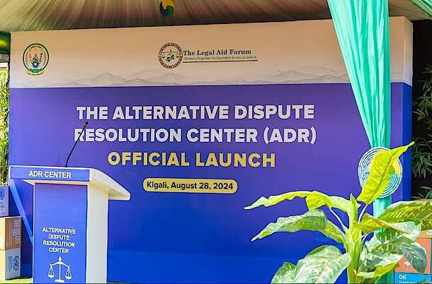

In August 2024, Rwanda inaugurated the Nyamirambo ADR Centre as a “multi-door” justice facility offering mediation, arbitration, conciliation, and plea bargaining. This development demonstrates Rwanda’s institutional commitment to embedding ADR within its justice system.

**4. The Impact of ADR in Rwanda**

**4.1. Efficiency and Cost Savings**

Between 2019 and 2022, mediation resolved nearly 3,000 cases, saving litigants an estimated RWF 11 billion. In the fiscal year 2023/24 alone, ADR resolved over 12,000 cases, generating savings of RWF 7.5 billion.

**4.2. Court Decongestion**

By diverting disputes from litigation, ADR mechanisms reduce the backlog of cases before the ordinary courts, allowing the judiciary to allocate resources to more complex or criminal cases.

**4.3. Social Harmony**

Mediation fosters reconciliation and community cohesion by promoting dialogue rather than adversarial confrontation. The Abunzi in particular reinforce Rwanda’s culture of collective problem-solving.

**4.4. Business and Investment Climate**

Arbitration, especially under KIAC, has enhanced Rwanda’s attractiveness to investors by providing efficient and enforceable dispute resolution mechanisms consistent with international standards.

**5. Challenges Facing ADR in Rwanda**

Despite significant progress, several challenges persist:

* **Limitations of Abunzi:** The informality of Abunzi proceedings may subject them to local political influence and social pressure, limiting their effectiveness in complex or high-stakes disputes.
* **Capacity Gaps:** There is a need for specialised training to equip mediators and arbitrators with advanced skills, particularly in commercial and international disputes.
* **Public Awareness:** Many Rwandans continue to equate justice with formal court proceedings, leading to underutilization of ADR.
* **Enforcement of Awards:** Although arbitral awards are enforceable under *Law No. 005/2008 of 14 February 2008 on Arbitration and Conciliation in Commercial Matters*, enforcement may face delays, especially in cross-border disputes.¹¹

**6. Conclusion and Recommendations**

Mediation and arbitration in Rwanda represent a dynamic convergence of traditional reconciliation mechanisms and modern statutory frameworks. By combining grassroots initiatives such as the Abunzi with institutions like KIAC, Rwanda has fostered an innovative justice system that emphasises accessibility, efficiency, and social harmony.

**Recommendations:**

1. Strengthen the training and accreditation of mediators and arbitrators.
2. Increase public awareness campaigns to build trust in ADR processes.
3. Streamline enforcement procedures for arbitral awards.
4. Encourage stronger public-private partnerships in ADR to sustain its growth.

Ultimately, ADR in Rwanda is evolving from a supplementary mechanism to a central pillar of justice delivery aligned with Rwanda’s broader national vision of unity, reconciliation, and sustainable development (*Vision 2050*).

**References**

1. Organic Law No. 02/2010/OL of 09/06/2010 Establishing Mediation Committees.
2. Organic Law No. 40/2000 of 26/01/2001 Setting up “Gacaca Jurisdictions.”
3. Law No. 21/2012 of 14/06/2012 Relating to the Civil, Commercial, Labour and Administrative Procedure Code (as amended 2018).
4. Rwanda Ministry of Justice, *National ADR Policy* (2022).
5. Law No. 51/2010 of 10/01/2010 Establishing the Kigali International Arbitration Centre (KIAC).
6. Rwanda Ministry of Justice, *Press Release on Nyamirambo ADR Centre Inauguration* (August 2024).
7. Ministry of Justice, *Annual Justice Sector Report* (2019–2022).
8. Ministry of Justice, *Annual Justice Sector Report* (2023/24).
9. UNCITRAL Model Law on International Commercial Arbitration (1985, amended 2006).
10. ACCORD, *The Abunzi Mediation in Rwanda: Justice and Reconciliation at the Grassroots* (2010).
11. Law No. 005/2008 of 14/02/2008 on Arbitration and Conciliation in Commercial Matters.